**HBase Assignment 2 – Python API1**

**Task1:**

**Access all the tables created in Assignment 1 and run those queries through the python API**

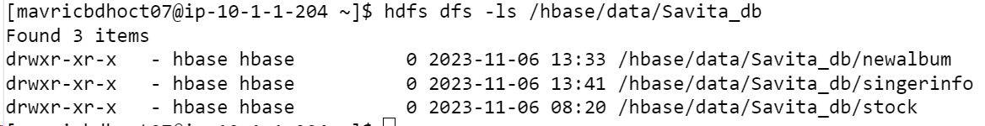

**Two tables created in Hbase assignment 1**

1. **Savita_db:stock**

2.**Savita_db:album**

**Table 1 Results**

Import happybase

>>> connection = happybase.Connection('10.1.1.204', 9090)

>>> table = connection.table('Savita_db:stock')

>>> for key, data in table.scan():

... print(key,data)

...

>>> for key, data in table.scan():

... print(key,data)

...

Queries:

1. What are the various comments given by all the users?

>>> import happybase

>>> table = connection.table('Savita_db:stock')

>>> connection = happybase.Connection('10.1.1.204', 9090)

>>> for key, data in table.scan(row_start=b'1', columns = [b'sampledata:comment']):

... print(key, data)

...

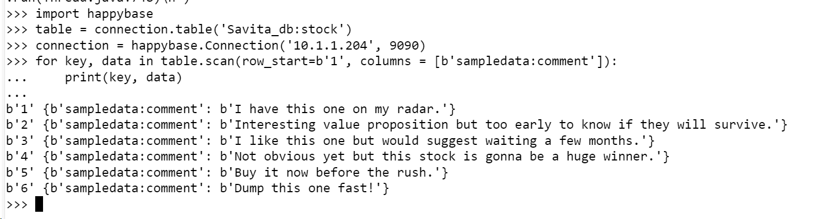

1. What are the comments by user3?

for key,data in table.scan(filter="SingleColumnValueFilter('sampledata','userid',=,'substring:user3')"):

print(key,data)

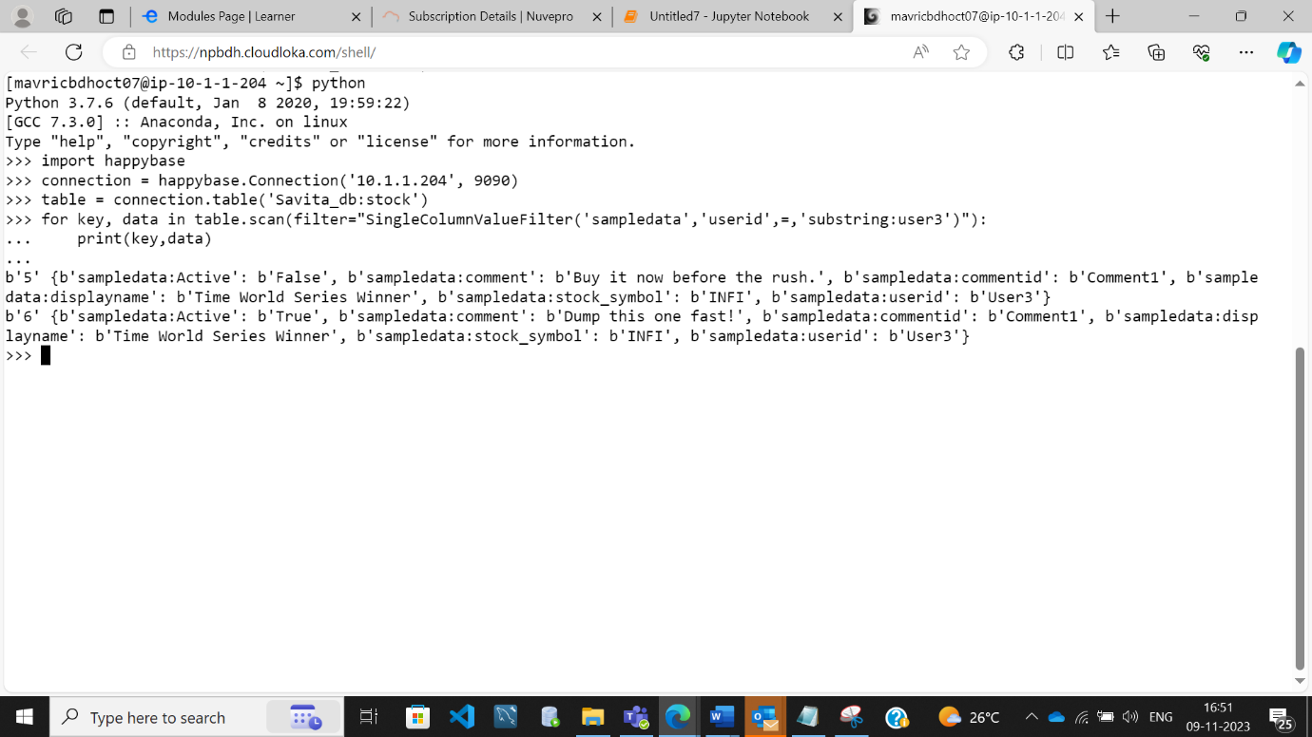

3) Which users have inactive comments?

**for key, data in table.scan(filter="SingleColumnValueFilter('sampledata','Active',=,'substring:False')"):**

**print(key,data)**

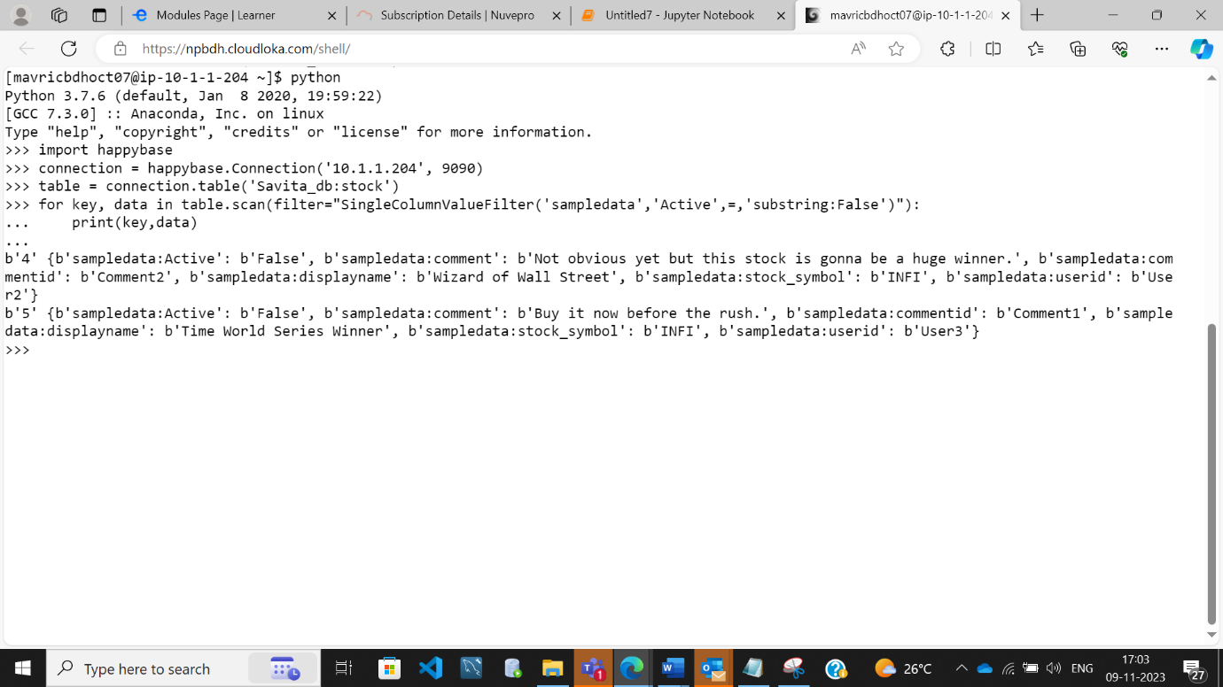

**Table 2 Results:**

import happybase

connection = happybase.Connection('10.1.1.204', 9090)

table = connection.table('Savita_db:singerinfo')

for key, data in table.scan():

print(key,data)

3. Run queries like

1) get all songs sung by a singer

for key, data in table.scan(filter="SingleColumnValueFilter('New','Song',=,'substring:Song')"):

print(key,data)

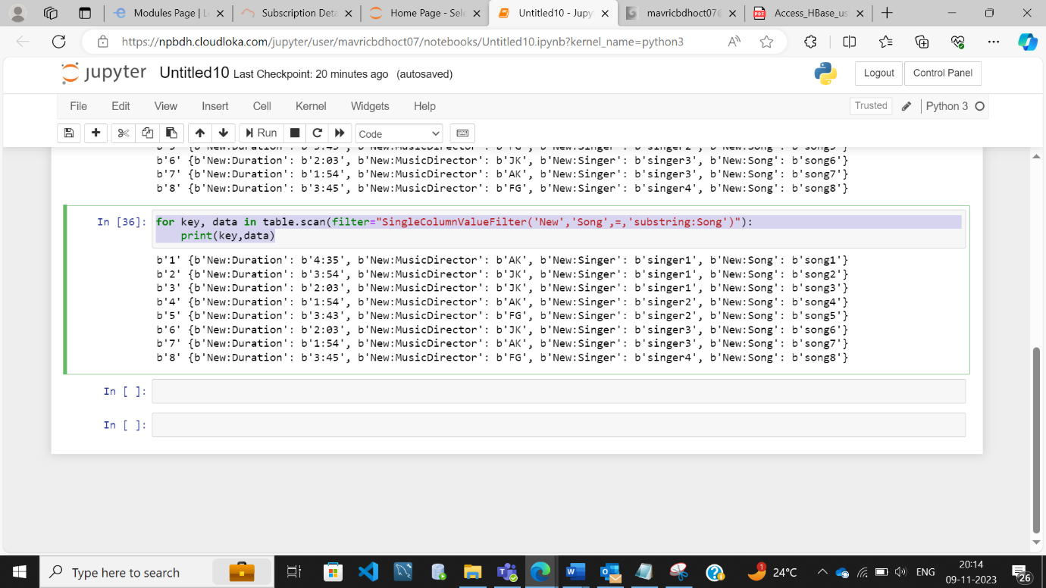

2) Which singer sung for music director AK and what were the songs

for key, data in table.scan(filter="SingleColumnValueFilter('New','MusicDirector',=,'substring:AK')"):

print(key,data)

**Task 2:**

**Also Create new tables from python and insert some data in to those tables**

import happybase

connection = happybase.Connection('10.1.1.204',9090,table_prefix='Savita_db')

connection.create_table(

'Employee',

{'info1': dict(max_versions=10),

'info2': dict(max_versions=1, block_cache_enabled=False),

'info3': dict(), # use defaults

}

)

print(connection.tables())

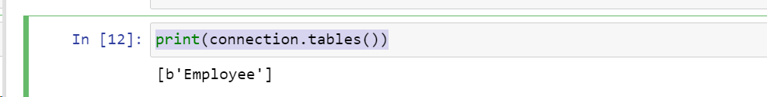

table = connection.table('Employee')

for i in range(15):

table.put(b'rowkey-%d'%(i), {b'info1:name': b'emp-%d'%(i),b'info2:city': b'%d'%(i)})

for key, data in table.scan():

print(key, data)

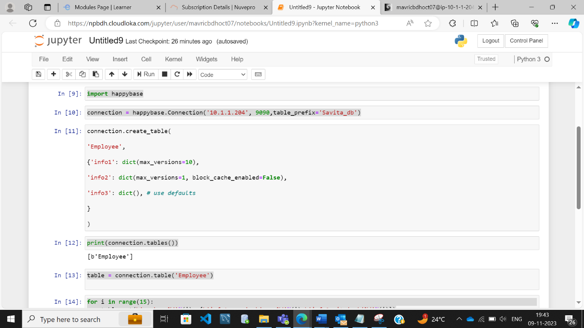

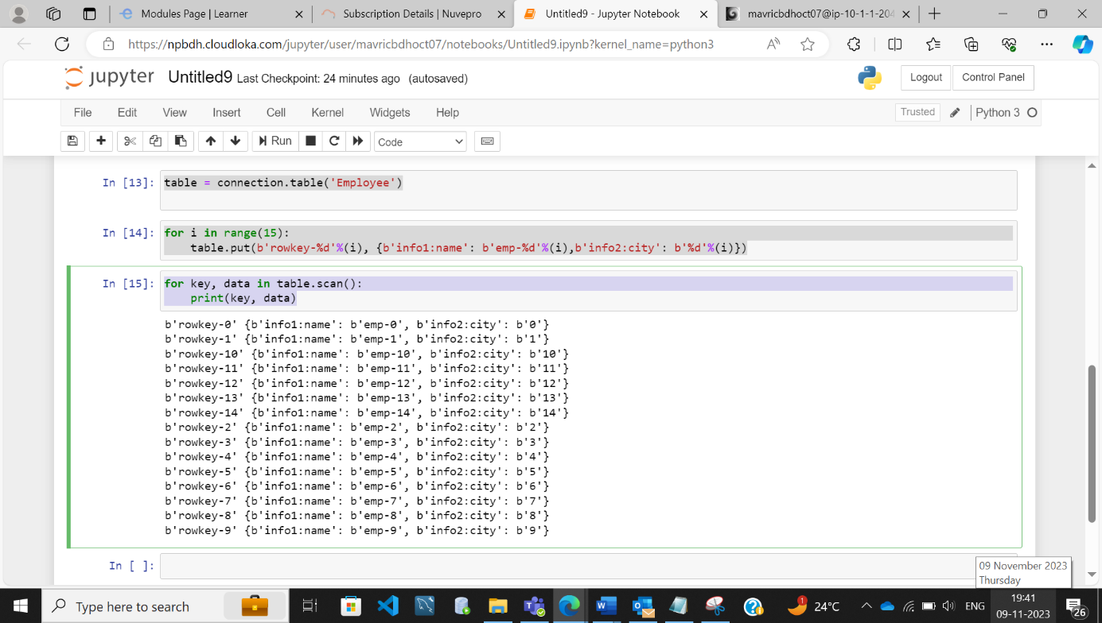

**OUTPUT:**

b'rowkey-0' {b'info1:name': b'emp-0', b'info2:city': b'0'}

b'rowkey-1' {b'info1:name': b'emp-1', b'info2:city': b'1'}

b'rowkey-10' {b'info1:name': b'emp-10', b'info2:city': b'10'}

b'rowkey-11' {b'info1:name': b'emp-11', b'info2:city': b'11'}

b'rowkey-12' {b'info1:name': b'emp-12', b'info2:city': b'12'}

b'rowkey-13' {b'info1:name': b'emp-13', b'info2:city': b'13'}

b'rowkey-14' {b'info1:name': b'emp-14', b'info2:city': b'14'}

b'rowkey-2' {b'info1:name': b'emp-2', b'info2:city': b'2'}

b'rowkey-3' {b'info1:name': b'emp-3', b'info2:city': b'3'}

b'rowkey-4' {b'info1:name': b'emp-4', b'info2:city': b'4'}

b'rowkey-5' {b'info1:name': b'emp-5', b'info2:city': b'5'}

b'rowkey-6' {b'info1:name': b'emp-6', b'info2:city': b'6'}

b'rowkey-7' {b'info1:name': b'emp-7', b'info2:city': b'7'}

b'rowkey-8' {b'info1:name': b'emp-8', b'info2:city': b'8'}

b'rowkey-9' {b'info1:name': b'emp-9', b'info2:city': b'9'}